CHEMISTRY AT WORK AT THE MAMALA RIVER
ARLENE A. ZABALA¹
^{1.2.} Bataan Peninsula State University
Email ID: arlenezabala1975@gmail.com

ABSTRACT
This mixed method study aimed to assess the physical, chemical and microbiological properties of the Mamala River of Limay, Bataan. Twenty-two respondents were selected using criteria sampling technique. The physical properties of the river in terms of color, temperature, turbidity and odor, chemical properties like pH, Total Dissolved Solids (TDS), Total Suspended Solids (TSS), Biological Oxygen Demand (BOD) and sediments like lead, chromium and cadmium and microbiological property in terms of E.coli were evaluated. Unstructured interview was conducted to determine the past and present condition of the river. The water samples were taken from 3 water point locations (WPL) which revealed that all WPLs have standard color and temperature. However, WPL 1 has high turbidity and greasy oily odor while WPL 2 and 3 have normal turbidity and no odor. All WPLs have increasing ph and standard DO, BDO and sediment contents. The TDS level of WPL 1 is unacceptable while it exceeded the maximum TSS value. WPLs 2 and 3 have TDS and TSS value which are within the standard limit and has no E.coli. Also, it has experienced dramatic physical change, decreased in aquatic fauna and increased in number of family settling around its banks. Activities that enhance socialization and religiosity between and among people were no longer conducted in the river.
It was recommended that strict monitoring on dumping activities of all boats in the river must be imposed. Ecological Solid Waste Management Act of 2000 and Clean Water Act of 2004 must be strictly enforced. Investments to create green corridors or bankside vegetation along the river must be prioritized. Restructuring the river as a tourism resource will boost local economy. Creation of Mamala River Warriors who will be composed of the out-of-school youth must be undertaken to work hand-in-hand with BPSU.
Keywords: Chemistry, Mamala River, Physical, Chemical and Microbiological Properties

INTRODUCTION
Historically, rivers are important in the old Philippine society since early Filipinos have established maritime and riverine culture which became the sources of their economy. Many of the civilizations that uniquely developed in the rural communities of the country started along riverbanks since most of the people that live therein found environmental, social and economic sustainability in those areas. The development crawls its way to the central plains where people saw the establishment of plants and everywhere became industrial spaces. The uses of the rivers have now changed and are no longer the center of developing civilization but are mainly used for fishing and in worse scenarios, dumping areas of garbage, both toxic and non-toxic.
The Philippines is endowed with 421 principal river basins that provide various services such as means for mobility and transport of people and goods, hydropower, recreation, and irrigation, among others [1] (Olatayo, 2014). Against this backdrop, however, [2] Naz (2013) noted that the Philippine rivers are now becoming polluted with up to 58% of groundwater contaminated with coliform and nearly 2.2 million metric tons of organic pollution are produced annually by domestic (48%), agricultural (37%), and industrial (15%) sectors. Moreover, [3] Tuddao (2009) also stated that rivers are faced with water-related management challenges which cover a wide range of concerns like pollution of surface water and groundwater as a result of urbanization, industrialization, indiscriminate land use and land development, and governance concerns due to overlapping functions among agencies working on water and water-related projects and programs.
In the province of Bataan, most of the towns are drained by numerous rivers, streams and creeks with very few meanders radiating and sloping from the mountain groups down to the sea draining the whole area very efficiently. However, [4] Baluyot and Reyes-Hina (2012) found out that the coastal environment of Bataan is currently facing environmental and ecological threats that endanger the sustainable livelihood and living condition of the communities in the coastal area. It eventually affects the economic activities that depend on the sea. Likewise, the Bataan Integrated Coastal Management Program (BICMP) which is tri-partite agreement among the Provincial Government of Bataan, the Bataan Coastal Care Foundation, Inc. and the Parnertships in Environmental Management for the Seas of East Asia (PEMSEA) Resource Facility, revealed in their study that the major environmental problems in Bataan as viewed by the various stakeholders are pollution from land-based activities, oil spills and other sea-based sources of pollution, siltation and sedimentation and multiple resource use conflicts and governance.
The research locale of this study, which is the Mamala River, was chosen since it runs through the commercial areas, public market and residential houses that loiter around its banks in Limay, a highly industrialized town and home to oil refinery and coal plants. Mamala River is a Class B river or Recreational Water Class 1 which is used primarily for contact recreation such as bathing, swimming and diving and particularly those designated for tourism purpose. The river flows east from Mt. Limay, parallel to and south of the town and drains at the Manila Bay [5] (Lagmay, 2012). The result of the geohazard assessment conducted by the provincial government of Bataan stated that riverbank erosion was observed in the active river and natural channels traversing the municipality of Limay such as Mamala River and Lamao River. Upon visit to the area, it can be noticed that many households and commercial establishments are draining their lavatories and comfort rooms to the river while some use it as dumping sites of both biodegradable and non-biodegradable wastes. A few years back, the river also suffered major setback when the dumping site of the town was opened one kilometer away from the western side of the river which may have also contributed to its current blackish color and stagnant condition.
The aforementioned information justifies the need to investigate the physical, microbiological and chemical properties content of the Mamala River of Limay. This will be done in order to determine the current state of the river by looking at the three water point locations in Brgy. Reformista, Brgy. Townsite and Brgy. Wawa. This study is actually the application of the laboratory experiments that involve the properties of water in a Chemistry class. The researcher, who has almost 20 years of experience in teaching the discipline, allowed her students to conduct laboratory class experiments that showed the properties of water and how it reacted with other substances. Students performed the experiment, collected the data, diagramed results, and generated a definition of the physical, biological and chemical properties of water. The principles to be used in the classroom can very well be utilized in a much larger body of water like the Mamala River with application of some chemical equations to determine the pollutants in the properties of its water. This is an example of a life-long learning where simple classroom Chemistry activities can be applied to study a larger community.
The coastal environment of Bataan is currently facing environmental and ecological threats that endanger the sustainable livelihood and living condition of the communities and affect the economic activities that depend on the sea. This study aimed to develop from the findings a community extension program along environmental sustainability such as protection and social sustainability like flood protection and recreation. This extension program is actually one of the trifocal mandates of Bataan Peninsula State University alongside instruction and research. Hence, it is necessary that research project like this must result to a data-driven extension program to help the community address the findings of the study.
Moreover, the general problem of the study is: How may the condition of the Mamala River of Limay serve as the basis for community education and extension program of Bataan Peninsula State University?
Specifically, this study sought answers to the following questions:
1. What are physical properties of the river in terms of
1.1 color,
1.2 temperature,
1.3 turbidity, and
1.4 odor?
2. What are the chemical properties of the river in terms of:
2.1 pH,
2.2 Total Dissolved Solids (TDS),
2.3 Total Suspended Solids (TSS),
2.4 Dissolved Oxygen (DO),
2.5 Biological Oxygen Demand (BOD),
2.6 sediments,
2.6.1 lead,
2.6.2 cadmium and
2.6.3 chromium?
3. What is the micromicrobiological property of the river in terms of Escherichia coli content?
4. How may the past and present condition of the river be compared in terms of:
4.1 environmental development and
4.2 social significance?
5. Based on the findings of the study, what community extension program may be designed for Bataan Peninsula State University pertaining to the environmental and socio-economic sustainability of the Mamala River?
RESEARCH METHODOLOGY
This study which aims to assess the physical, chemical and microbiological properties of the Mamala River of Limay utilized the mixed method. In this approach, the researcher collected, analysed, and integrated both quantitative and qualitative data in a single study or in a sustained long-term program of inquiry to address their research questions [6] (Creswell, 2013). This mixed methods study addressed the need to design a feasible extension program for the people in the community along the riverbanks.
For [7] Creswell and Piano (2007), mixed methods research is a research design with philosophical assumptions as well as methods of inquiry. As a methodology, it involves philosophical assumptions that guide the direction of the collection and analysis of data and the mixture of qualitative and quantitative data in a single study or series of studies. Its central premise is that the use of quantitative and qualitative approaches in combination provides a better understanding of research problems that either approach alone.
For this study, a convergent parallel mixed methods design was used. It is a type of design in which qualitative and quantitative data are collected in parallel, analysed separately, and then merged [6] (Creswell, 2013). The quantitative data are the findings on the E. coli content and physical properties of the river in terms of color, temperature, turbidity, odor and sediments like lead, chromium and cadmium and chemical properties of the river in terms of pH, Total Dissolved Solids (TDS), Total Suspended Solids (TSS), Dissolved Oxygen (DO) and Biological Oxygen Demand (BOD). On the other hand, the qualitative data are sourced out from the interview which will explore past and present condition of the river in terms of environmental development and social significance for communities along the riverbanks. The reason for collecting both quantitative and qualitative data is to design and propose a community extension program along environmental and socio-economic sustainability of the Mamala River.
Moreover, the framework guide the researcher in understanding the relationship of the variables under input, the different mechanisms used in data gathering and analysis under output and the output of the study.
Figure 1
Paradigm of the Study
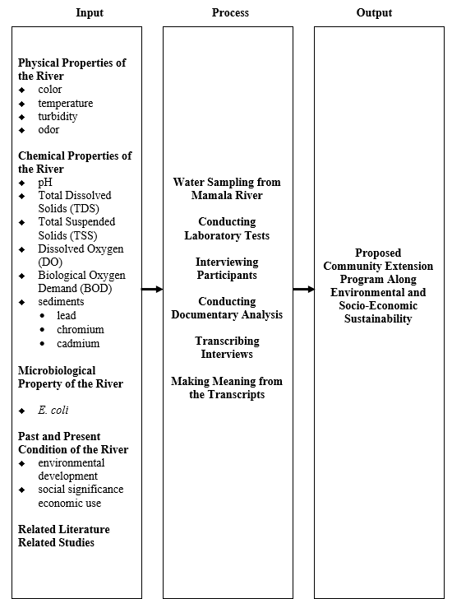
Figure 1 presents the paradigm of the study. In this study, the researcher used input (I) - process (P) - output (O) approach. A conceptual framework can guide research by providing a visual representation of theoretical constructs (and variables) of interest.
The first frame presents the input which pertains to the physical properties of the river in terms of color, temperature, turbidity, and odor. It also contains the chemical properties of the river in terms of pH, Total Dissolved Solids (TDS), Total Suspended Solids (TSS), Dissolved Oxygen (DO) and Biological Oxygen Demand (BOD) and sediments like lead, chromium and cadmium. The E. coli content of the river is likewise contained in the first frame, as well as the past and present conditions of the river in terms of environmental development and social significance.
The second frame pertains to the processes which include the water sampling from the Mamala River, conducting laboratory tests, interviewing participants, conducting documentary analysis to determine the environmental and socio-economic sustainability of the river over the years and determine the physical and chemical properties and E. coli content of the river.
The third frame contains the output of the study which is the proposed community extension program of Bataan Peninsula State University along environmental and socio-economic sustainability.
The input provided the essential factors that needed to be investigated in order to answer the general and specific problems posted by the present study. The process served as the guiding mechanisms in gathering and analyzing all the data needed to achieve the necessary output of the study which was the proposed community education and extension program along environmental and socio-economic sustainability.

RESEARCH FINDINGS
For the physical properties of the Mamala River, the following indicators were tested and explored: color, temperature, turbidity and odor. Table 5 presents the physical property of the Mamala River based on the said inidactors.
Part 1: Physical Properties of the Mamala River
Physical Property of Mamala River
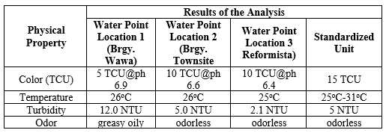

For the physical property of the river, water point locations 3 and 2 have an apparent color of 10 TCU while water point location 1 has a color of 5 TCU. In terms of temperature, water point location 3 has a temperature of 25oC while water point locations 1 and 2 have a temperature of 26oC. In terms of turbidity, water point location 3 has a turbidity of 2.1, water point location 2 with 5.0 NTU and water point location 1 with 12.0 NTU. In terms of odor, water point locations 3 and 2 have an odorless water while water point location 1 has a greasy oily odor.
Part II: Chemical Properties of the Mamala River
Chemical Property of Mamala River 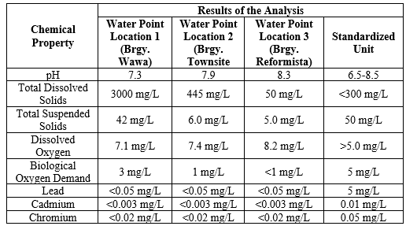
For the chemical property of the river, water point location 3 has 8.3 pH, water point location 2 with 7.9 pH and water point location 1 with 7.3 pH. In terms of total dissolved solids (TDS), water point location 1 has a TDS of 3000 mg/L, water point location 2 with 445 mg/L TDS and water point location 3 with 50 mg/L TDS. In terms of total suspended solids (TSS), water point location 1 has 40 mg/L TSS, water point location 2 with 6.0 mg/L TSS and water point location 3 with 5.0 mg/L. In terms of dissolved oxygen (DO), water point location 3 has 8.2 mg/L DO while water point location 2 with 7.4 mg/L DO and water point location 1 with 7.1 mg/L DO. In terms of biological oxygen demand (BOD), water point location 1 has 3 mg/L BOD level, water point location has 2 with 1 mg/L BOD and water point location 3 has < 1 mg/L BOD. All water point locations have a lead content of < 0.05 mg/L. All water point locations have a cadmium level of < 0.003 mg/L. All water point locations have a chromium level of < 0.02 mg/L.
Part III: Microbiological Property of Mamala River
Table 3
Microbiological Property of Mamala River
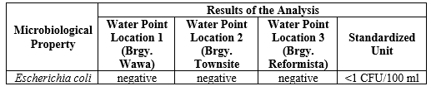
For the microbiological property of the Mamala River, Escherichia coli content was explored using sample water from each water point location. Table 3 presents the biological property of the Mamala River in terms of Escherichia coli content.
Escherichia coli. It can be deduced from Table 3 that all three water point locations are negative to Escherichia coli content. Escherichia coli or E. coli is a type of fecal coliform bacteria commonly found in the intestines of animals and humans [8] (Blaustein, Pachepsky, Hill, Shelton and Whelan, 2013). The presence of Escherichia coli in water is a strong indication of recent sewage or animal waste contamination which may contain many types of disease-causing organisms. Interestingly, while it is true that households especially in water point location 1 dump their wastes in the river and has a high turbidity level, no presence of E. coli is detected.
The negative results of the E. coli content in all three water point locations may be due to the fact that the river has a warmer temperature as manifested. [9] As pointed out by Miyanaga, Unno and Tanji (2006), the survival of E. coli exposed to river water was inversely proportional to temperature (5 to 15°C). It means that cooler water temperatures can increase the ability of E. coli to survive in a variety of aquatic conditions. A decrease in water temperature may prolong the ability of E. coli to survive in lake water, and may increase the health risk for aquatic organisms. Hence, E. coli survived for longer periods, mainly because of the decreased effect of U.V. light which is partially adsorbed by the more turbid waters like that of in water point location
Part IV: Past and Present Condition of the Mamala River in Terms of Environmental Development and Social Significance
For the environmental development, the following themes were developed changes in river’s physical appearance, decline in aquatic fauna and increasing human settlements around the river. On the other hand, for the social significance, two themes - ceasing socialization function and diminishing religious role of the river – were developed.
Part V: Community Extension Program Designed for Bataan Peninsula State University Pertaining to the Environmental and Socio-Economic Sustainability of the Mamala River
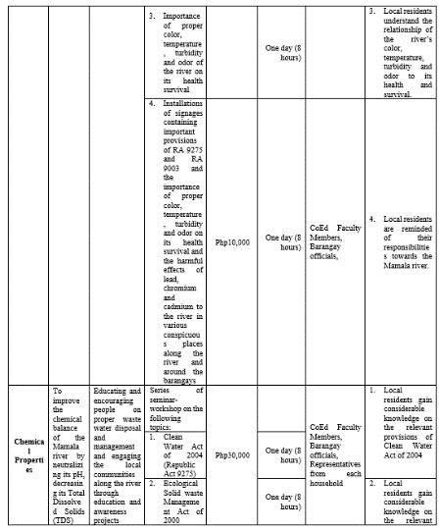
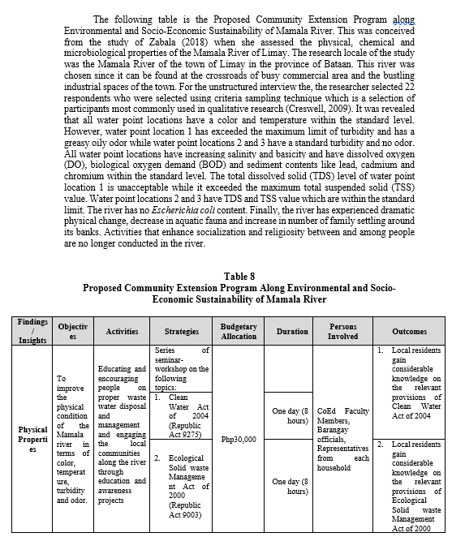
The proposed community program by the researcher was based on the quantitative and qualitative findings of the study. It focused along environmental and socio-economic sustainability of Mamala River which will draw relationships with the local government unit of Limay, local barangay officials, the out-of-school youth and the local church leaders in the area. Table 8 presents the proposed community extension program along environmental and socio-economic sustainability of Mamala River.
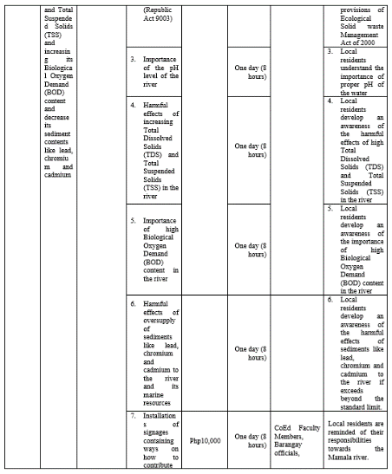
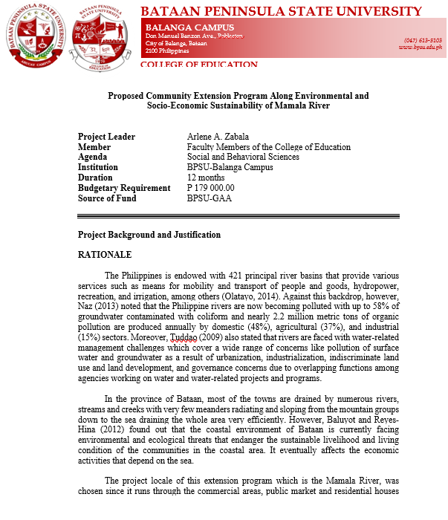

Time Duration: Year round

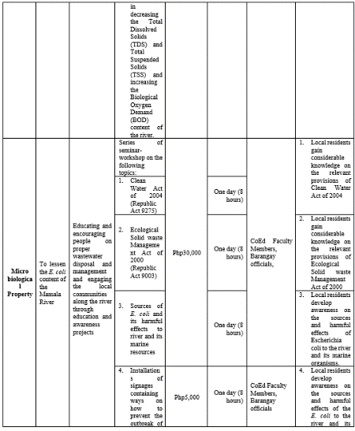

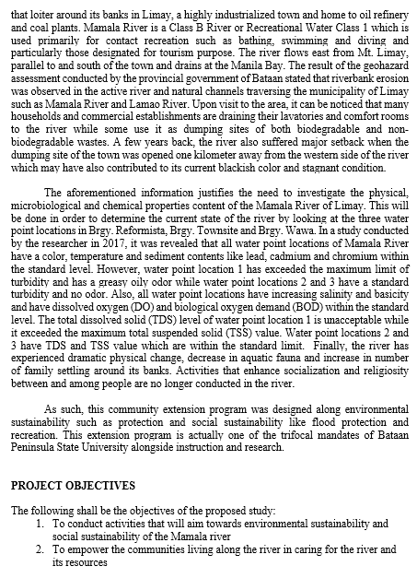

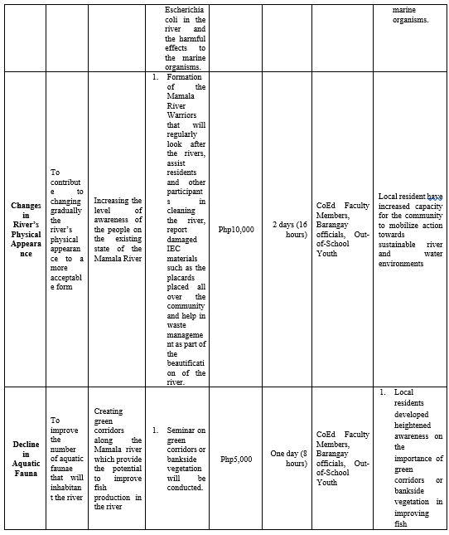

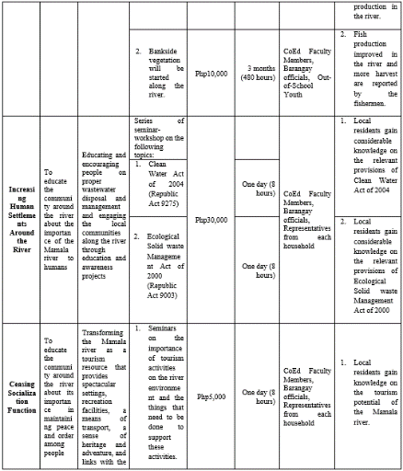

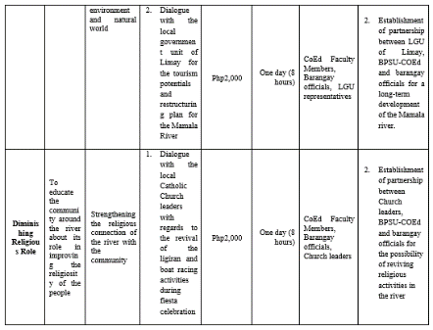

DISCUSSION
This mixed method study aimed to assess the physical, chemical and microbiological properties of the Mamala River of Limay. Specifically, this study described the physical, chemical and the microbiological properties of the river. Unstructured interview was conducted to determine the past and present condition of the river in terms of environmental development and social significance.
Based on the data gathered, the following were the salient findings of the study:
On the Physical Properties of the River
For the physical property of the river, water point locations 3 and 2 have an apparent color of 10 TCU while water point location 1 has a color of 5 TCU. In terms of temperature, water point location 3 has a temperature of 25oC while water point locations 1 and 2 have a temperature of 26oC. In terms of turbidity, water point location 3 has a turbidity of 2.1, water point location 2 with 5.0 NTU and water point location 1 with 12.0 NTU. In terms of odor, water point locations 3 and 2 have an odorless water while water point location 1 has a greasy oily odor.
On the Chemical Properties of the River
For the chemical property of the river, water point location 3 has 8.3 pH, water point location 2 with 7.9 pH and water point location 1 with 7.3 pH. In terms of total dissolved solids (TDS), water point location 1 has a TDS of 3000 mg/L, water point location 2 with 445 mg/L TDS and water point location 3 with 50 mg/L TDS. In terms of total suspended solids (TSS), water point location 1 has 40 mg/L TSS, water point location 2 with 6.0 mg/L TSS and water point location 3 with 5.0 mg/L. In terms of dissolved oxygen (DO), water point location 3 has 8.2 mg/L DO while water point location 2 with 7.4 mg/L DO and water point location 1 with 7.1 mg/L DO. In terms of biological oxygen demand (BOD), water point location 1 has 3 mg/L BOD level, water point location has 2 with 1 mg/L BOD and water point location 3 has < 1 mg/L BOD. All water point locations have a lead content of < 0.05 mg/L. All water point locations have a cadmium level of < 0.003 mg/L. All water point locations have a chromium level of < 0.02 mg/L.
On the Microbiological Property of the River
All three water point locations are negative to Escherichia coli content.
On the Comparison between the Past and Present Condition of the River
For the environmental development, the following themes were developed changes in river’s physical appearance, decline in aquatic fauna and increasing human settlements around the river. On the other hand, for the social significance, two themes - ceasing socialization function and diminishing religious role of the river – were developed.
On the Community Extension Program Designed for Bataan Peninsula State University Pertaining to the Environmental and Socio-Economic Sustainability of the Mamala River
A community extension program was proposed for the BPSU which addressed Mamala River’s environmental and socio-economic sustainability.
CONCLUSION
Based on the findings of the study, the following conclusions were made:
All water point locations have a color and temperature within the standard level. However, water point location 1 has exceeded the maximum limit of turbidity and has a greasy oily odor while water point locations 2 and 3 have a standard turbidity and no odor.
All water point locations have increasing salinity and basicity and have dissolved oxygen (DO), biological oxygen demand (BOD) and sediment contents like lead, cadmium and chromium within the standard level. The total dissolved solid (TDS) level of water point location 1 is unacceptable while it exceeded the maximum total suspended solid (TSS) value. Water point locations 2 and 3 have TDS and TSS value which are within the standard limit.
The river has no Escherichia coli content.
The river has experienced dramatic physical change, decrease in aquatic fauna and increase in number of family settling around its banks. Activities that enhance socialization and religiosity between and among people are no longer conducted in the river.

RECOMMENDATIONS
Based on the conclusions of the study, the following recommendations were made:
Strict monitoring on the entry and exit and dumping activities of all fishermen’s boats along Brgy. Wawa must be undertaken to prevent further oil spill to decrease the turbidty of the water in the area.
Important provisions of Ecological Solid Waste Management Act of 2000 (Republic Act 9003) and Clean Water Act of 2004 (Republic Act 9275) regarding proper waste water disposal and management must be strictly enforced by the concerned local government units especially among households in water point location 1 or around Brgy. Wawa to decrease the total dissolved solid (TDS) and total suspended solid (TSS) in the said area.
The local government units must invest to create green corridors or bankside vegetation along the Mamala river which will provide the potential to improve fish production in the river.
Restructuring the river as a tourism resource that will provide spectacular settings, recreation facilities, a means of transport, a sense of heritage and adventure, and links with the environment and natural world must form part of the strategic plan of the Municipality of Limay. In this juncture, the LGU may partner with Bataan Peninsula State University in conducting this activity.
Creation of Mamala River Warriors who will be composed of the out-of-school youth in close cooperation with the barangay officials must be undertaken to work hand-in-hand with Bataan Peninsula State University in the implementation of the Proposed Community Extension Program Along Environmental and Socio-Economic Sustainability of Mamala River
REFERENCES
[1] Olatayo, Ajibare Adefemi. (2014). Assessment of Physico-Chemical Parameters of Waters in Ilaje Local Government Area of Ondo State, Nigeria. International Journal of Fisheries and Aquatic Studies, 1(5): 84-92.
[2] Naz, Antonia Corinthia. (2013). The State of the Philippine Environment: An Update on Chapter 4 of the 1994 Philippine Human Development Report. Philippine Human Development Reports, Issue 10.
[3] Tuddao, Vicente. (2009). Framework planning for basin-level management - the Philippine approach. Center for River Basin Organizations and Management, Solo, Central Java, Indonesia.
[4] Baluyot, Alexander M. and Maria Carmelita Reyes-Hina. (2012). Developing the coastal land and sea use zoning plan: the Bataan experience. Expert Consultation Workshop on Coastal and Marine Spatial Planning Approach: International Experiences. East Asian Seas Congress.
[5] Lagmay, A.M.F. (2012). Disseminating near real-time hazards information and flood maps in the Philippines through Web-GIS. DOST-Project NOAH Open-File Reports, 1: 28-36.
[6] Creswell, J. W., (2013). Designing and conducting mixed methods research (2nd ed.). Thousand Oaks, CA: Sage Publications, Inc.
[7] Creswell, J.W. and Plano Clark, V.L. (2007). Designing and conducting mixed methods research. Sage, Thousand Oaks, California.
[8] Blaustein, R.A., Y. Pachepsky, R.L. Hill, D.R. Shelton and G. Whelan. (2013). Escherichia coli survival in waters: Temperature dependence. Water Research, 47: 569-578.
[9] Miyanaga, K., Unno, H., Tanji, Y. (2006). The survival response of Escherichia coli K12 in a natural environment. Applied Microbiology and Biotechnology 72 (2), 386-392.

